1. File->New->Other…

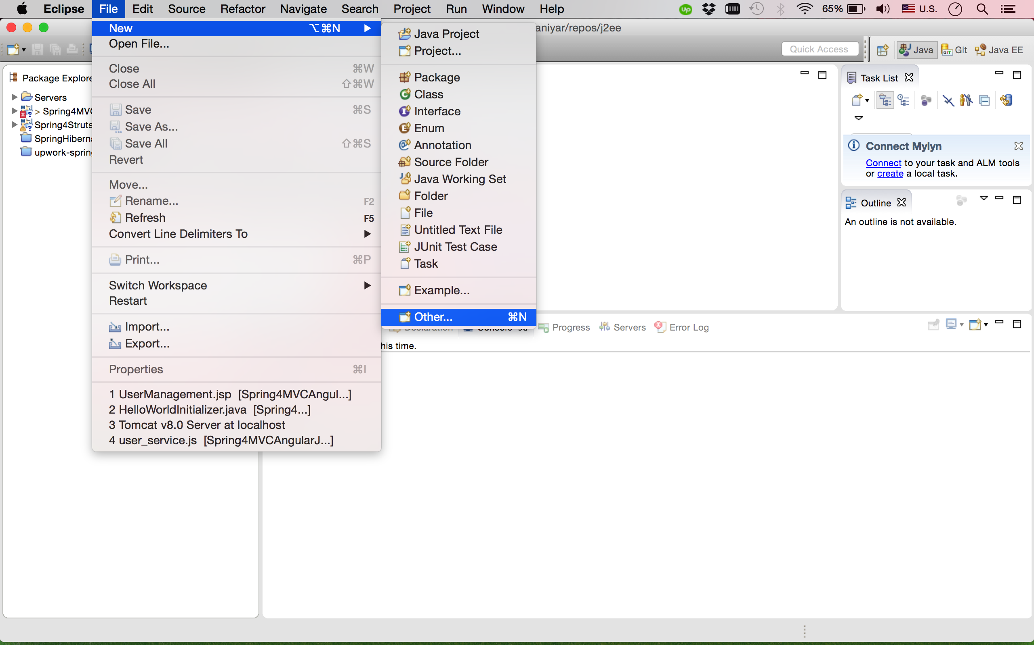

2. then choose Maven Project and press Next

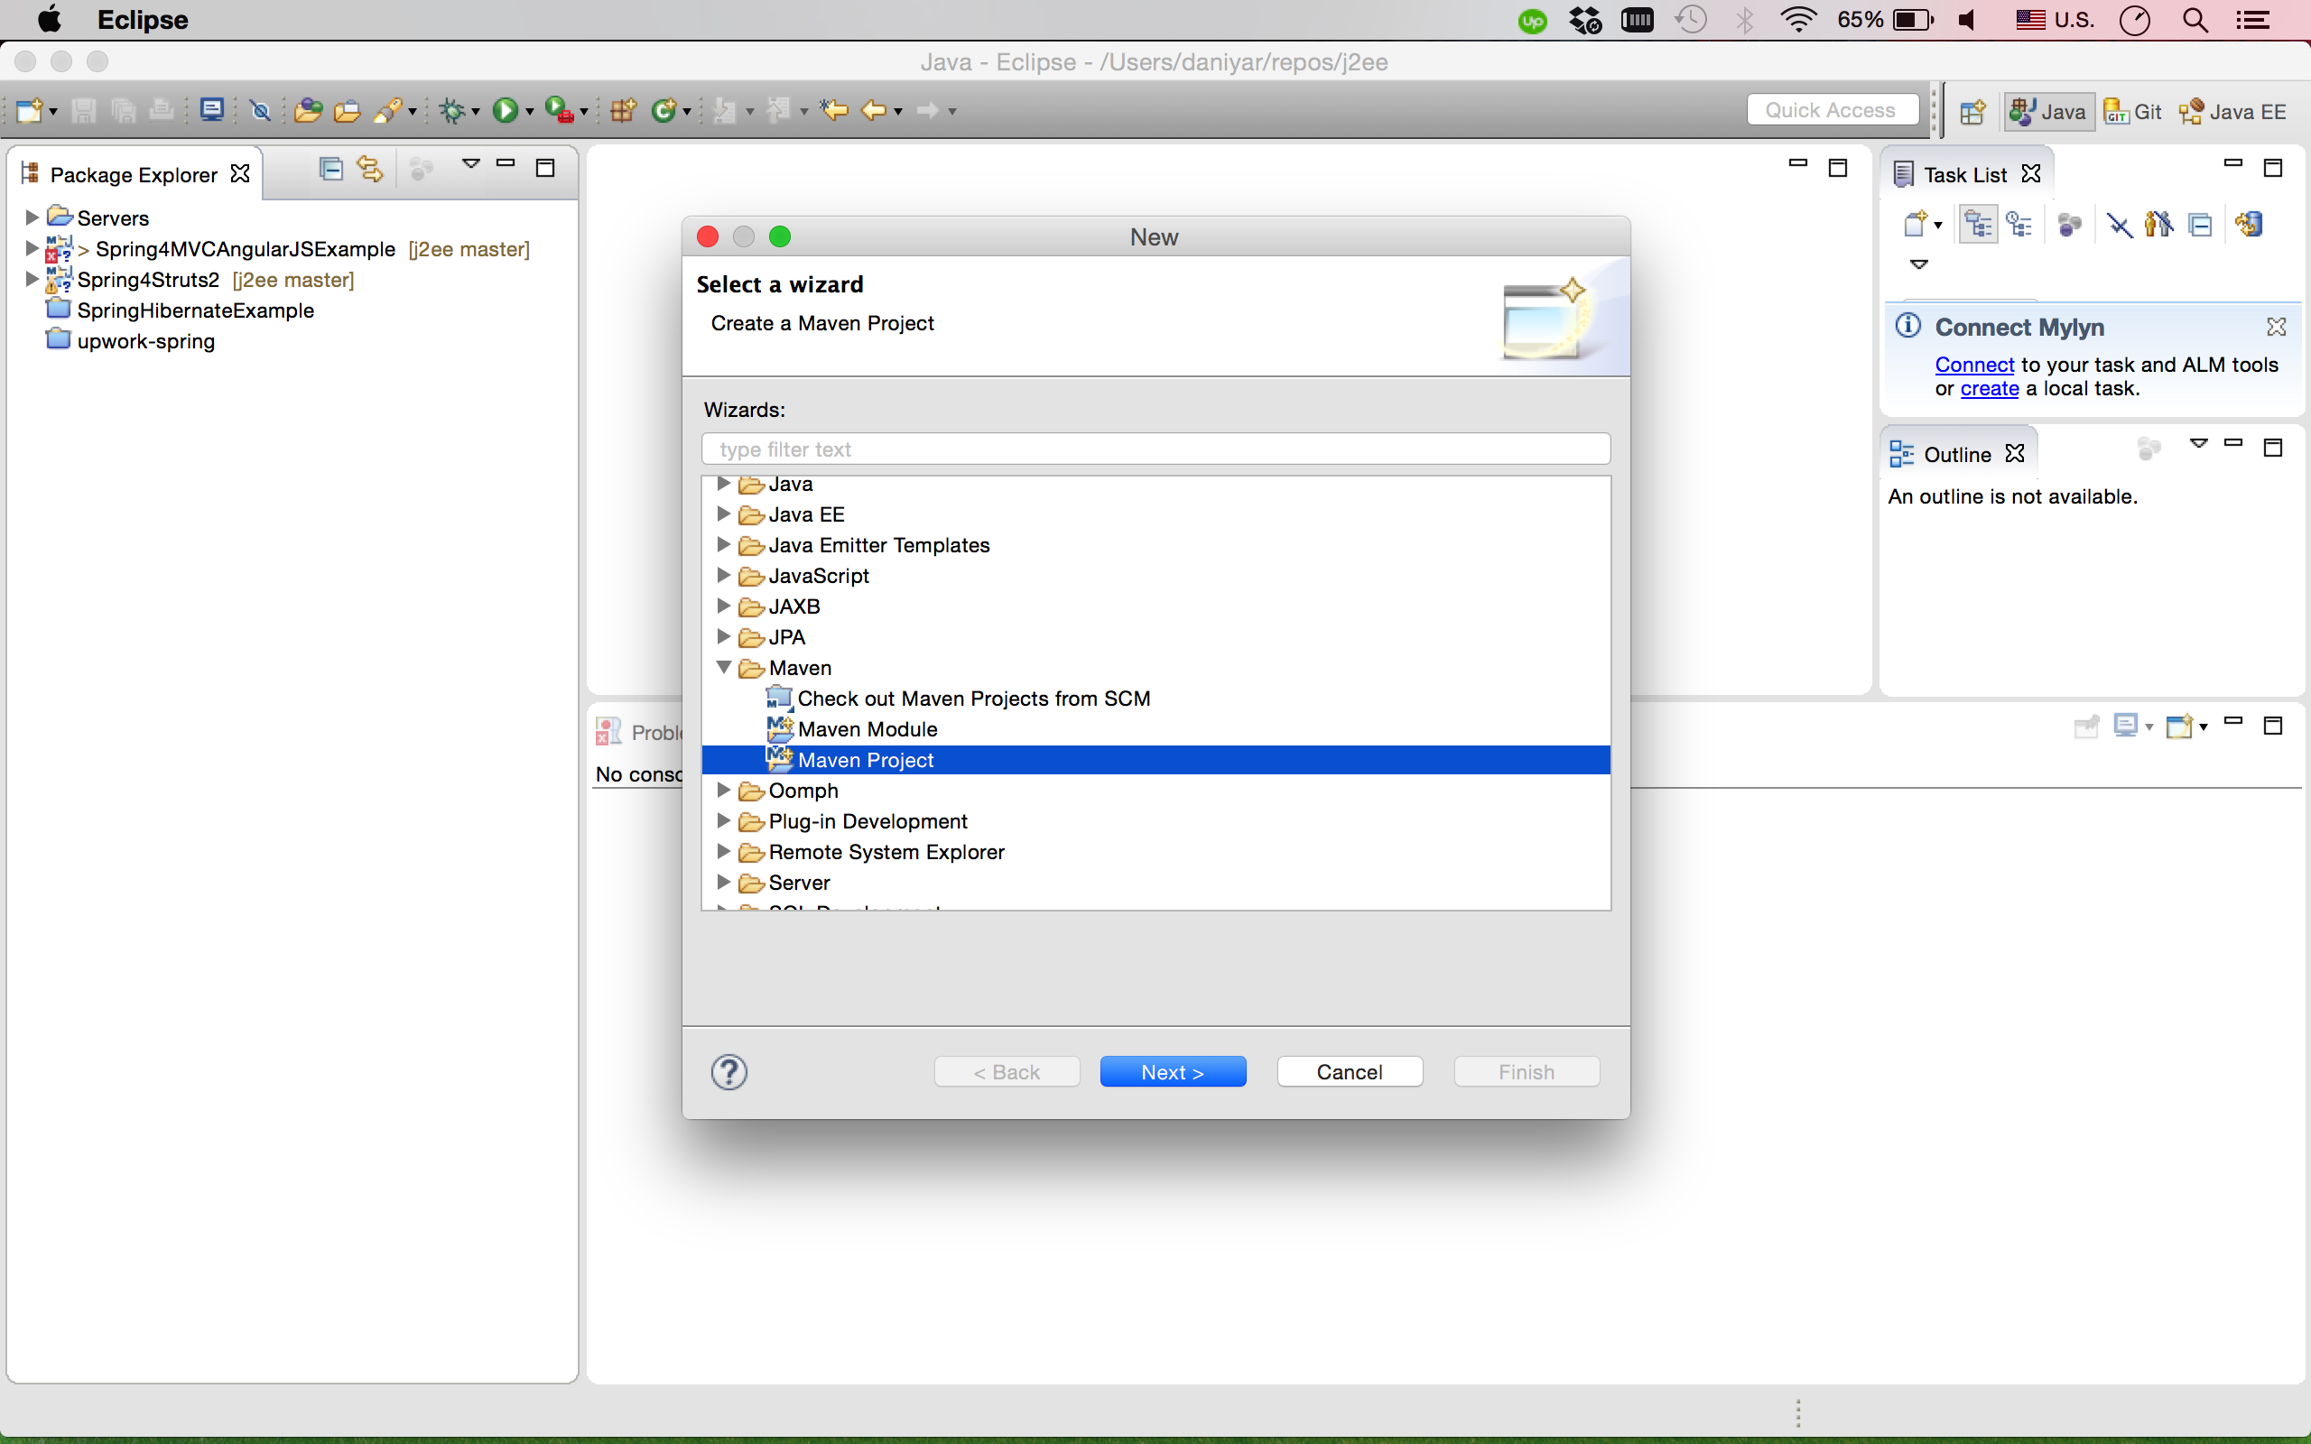

3. after mark «Create a simple project (skip archetype selection) then press next

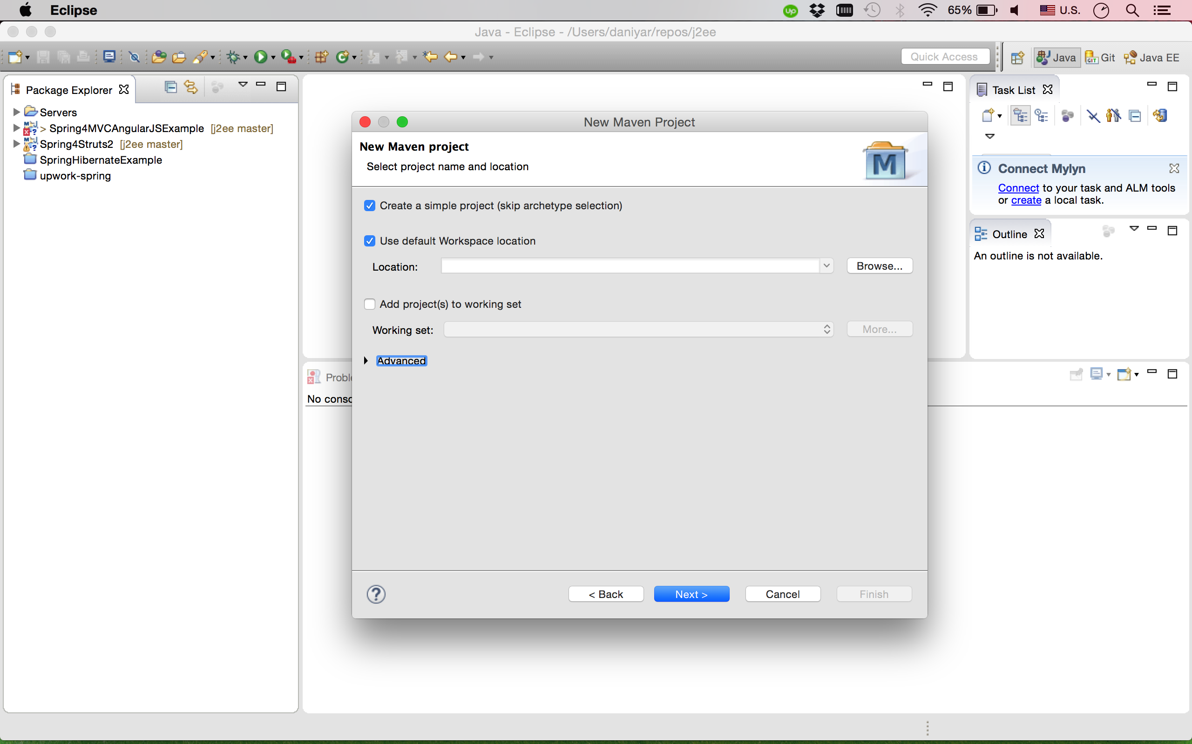

4. After that in Group Id write com.fdmgroup, in Artifact Id ODDDay1 (name of the project) then click Finish

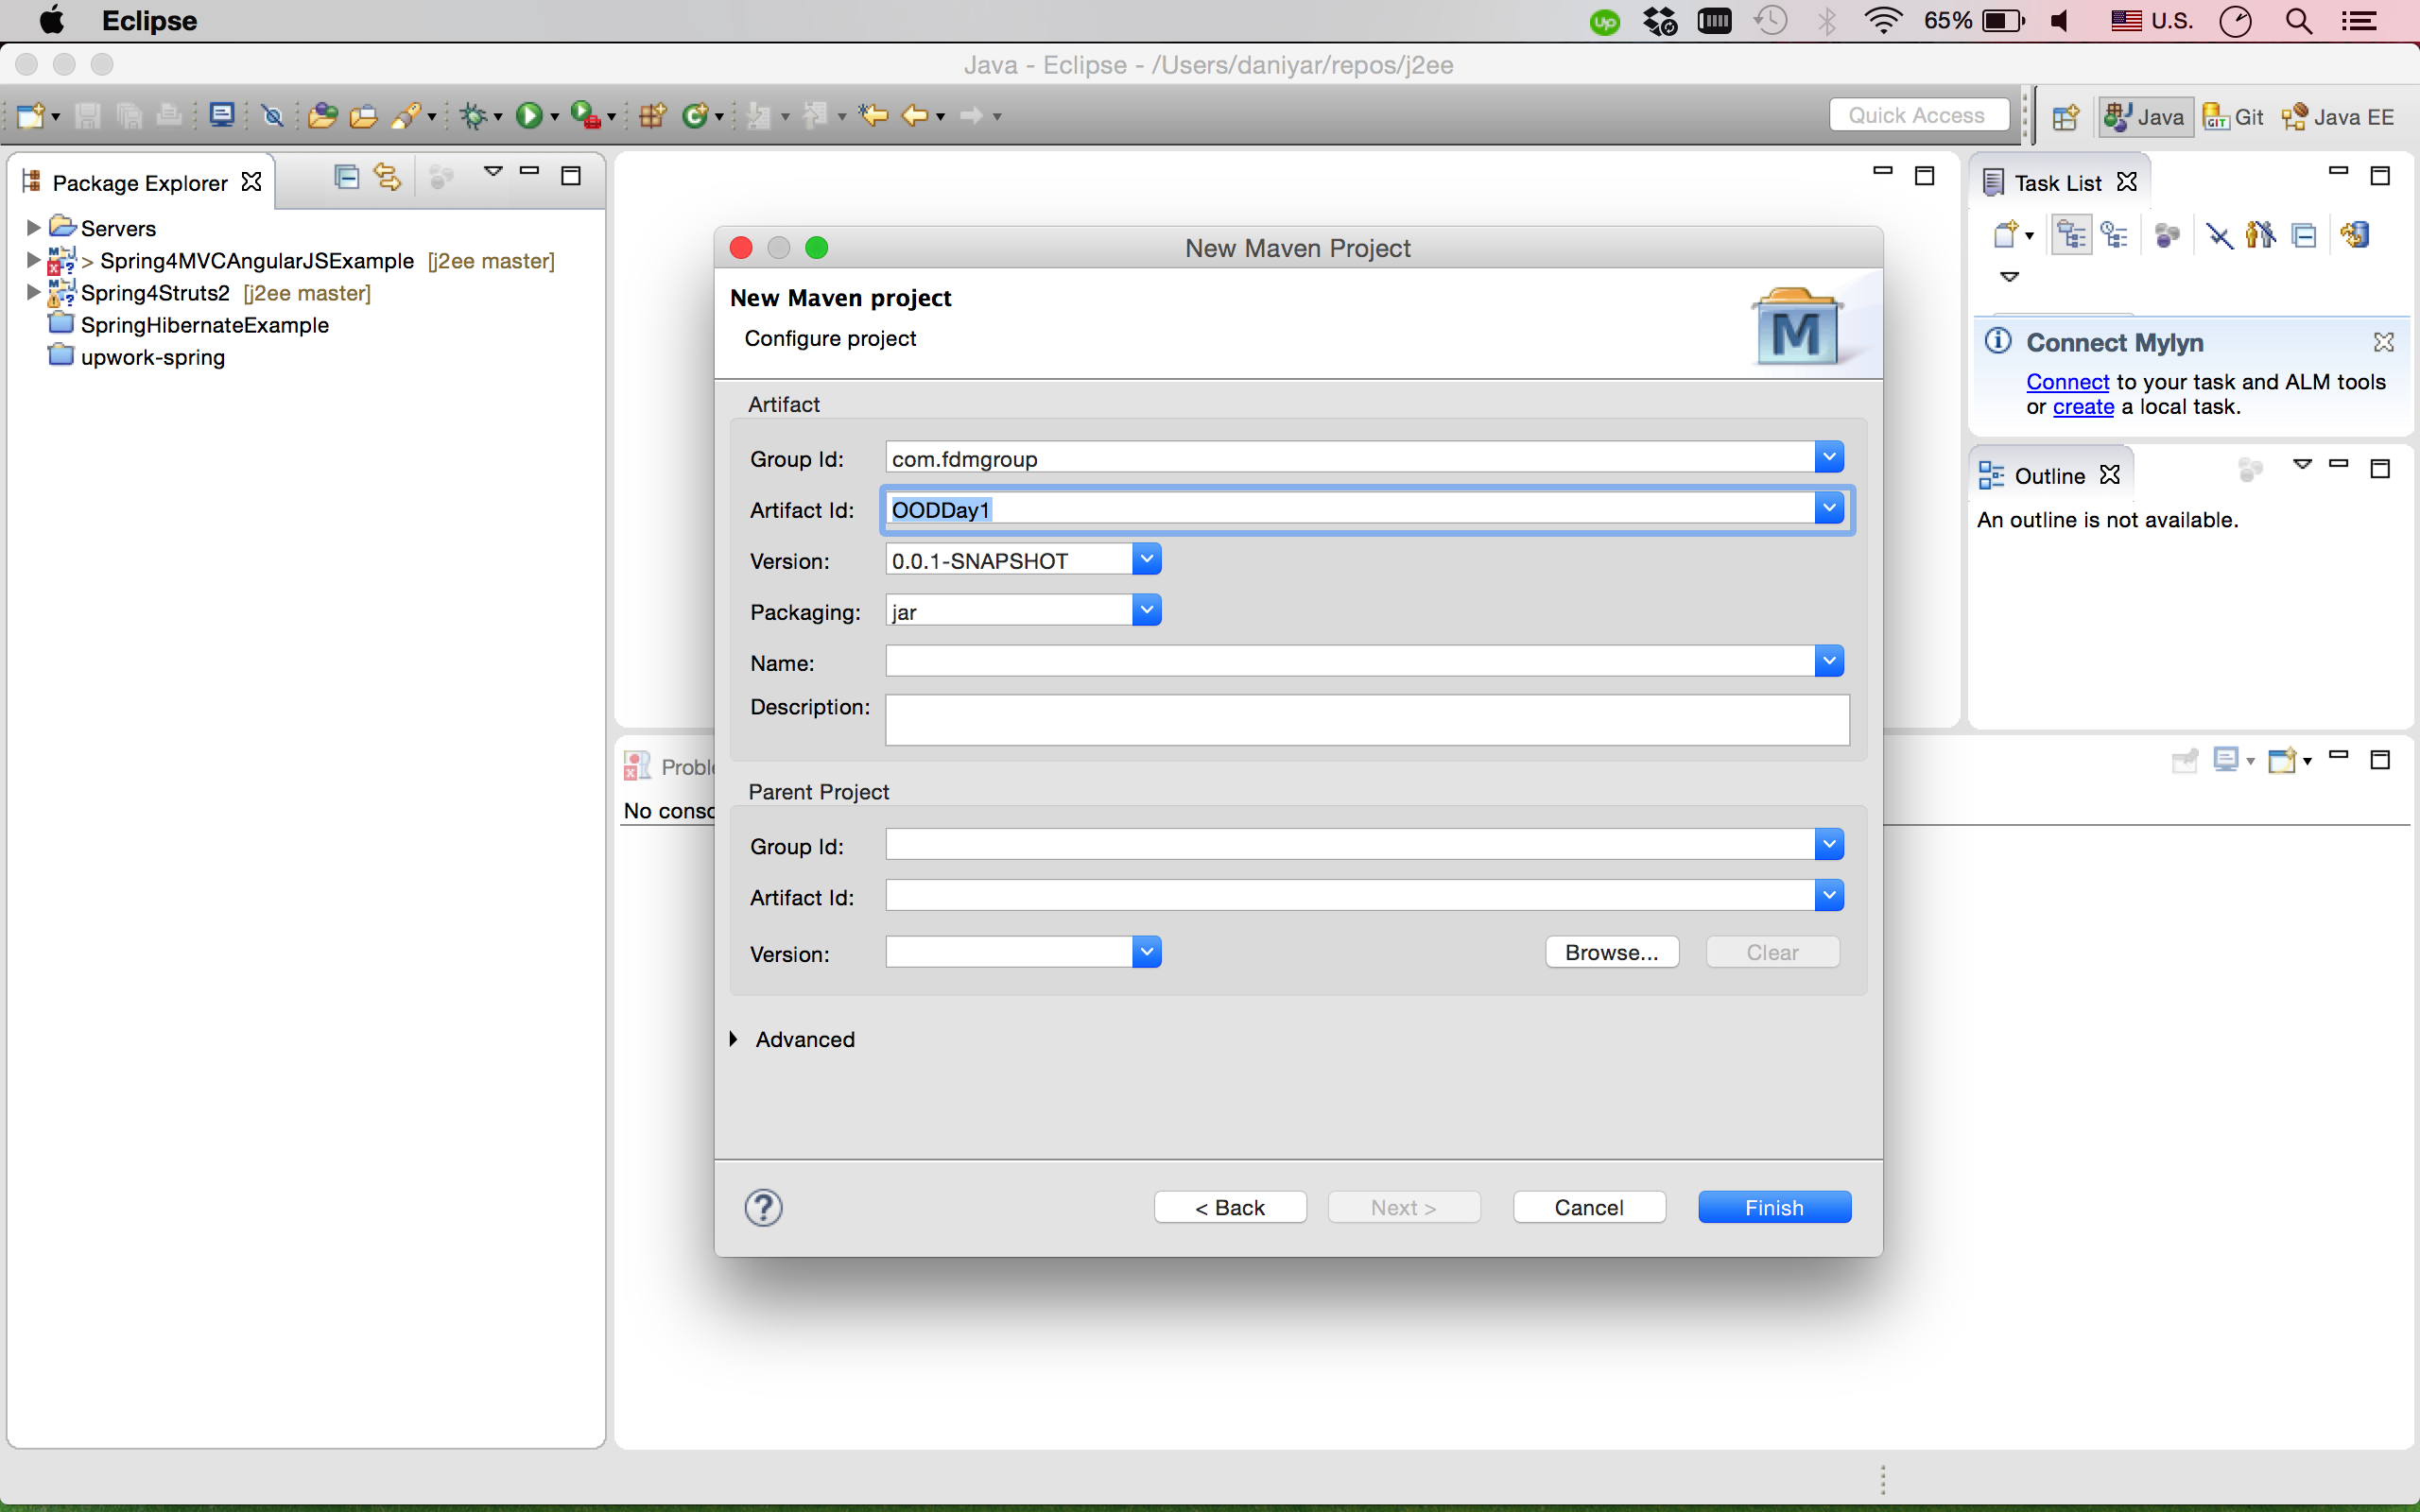

5. Now project created, we need to create package to task #1, in src/main/java folder click mouse right click

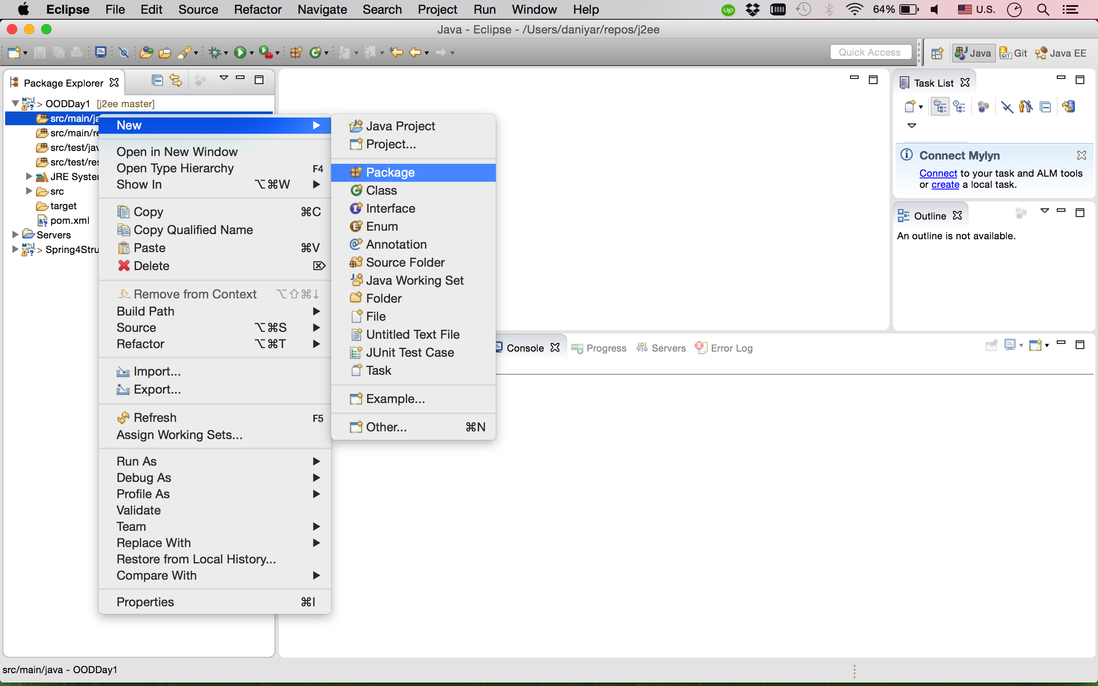

and enter name of the package com.fdmgroup.fizzbuzz.task1

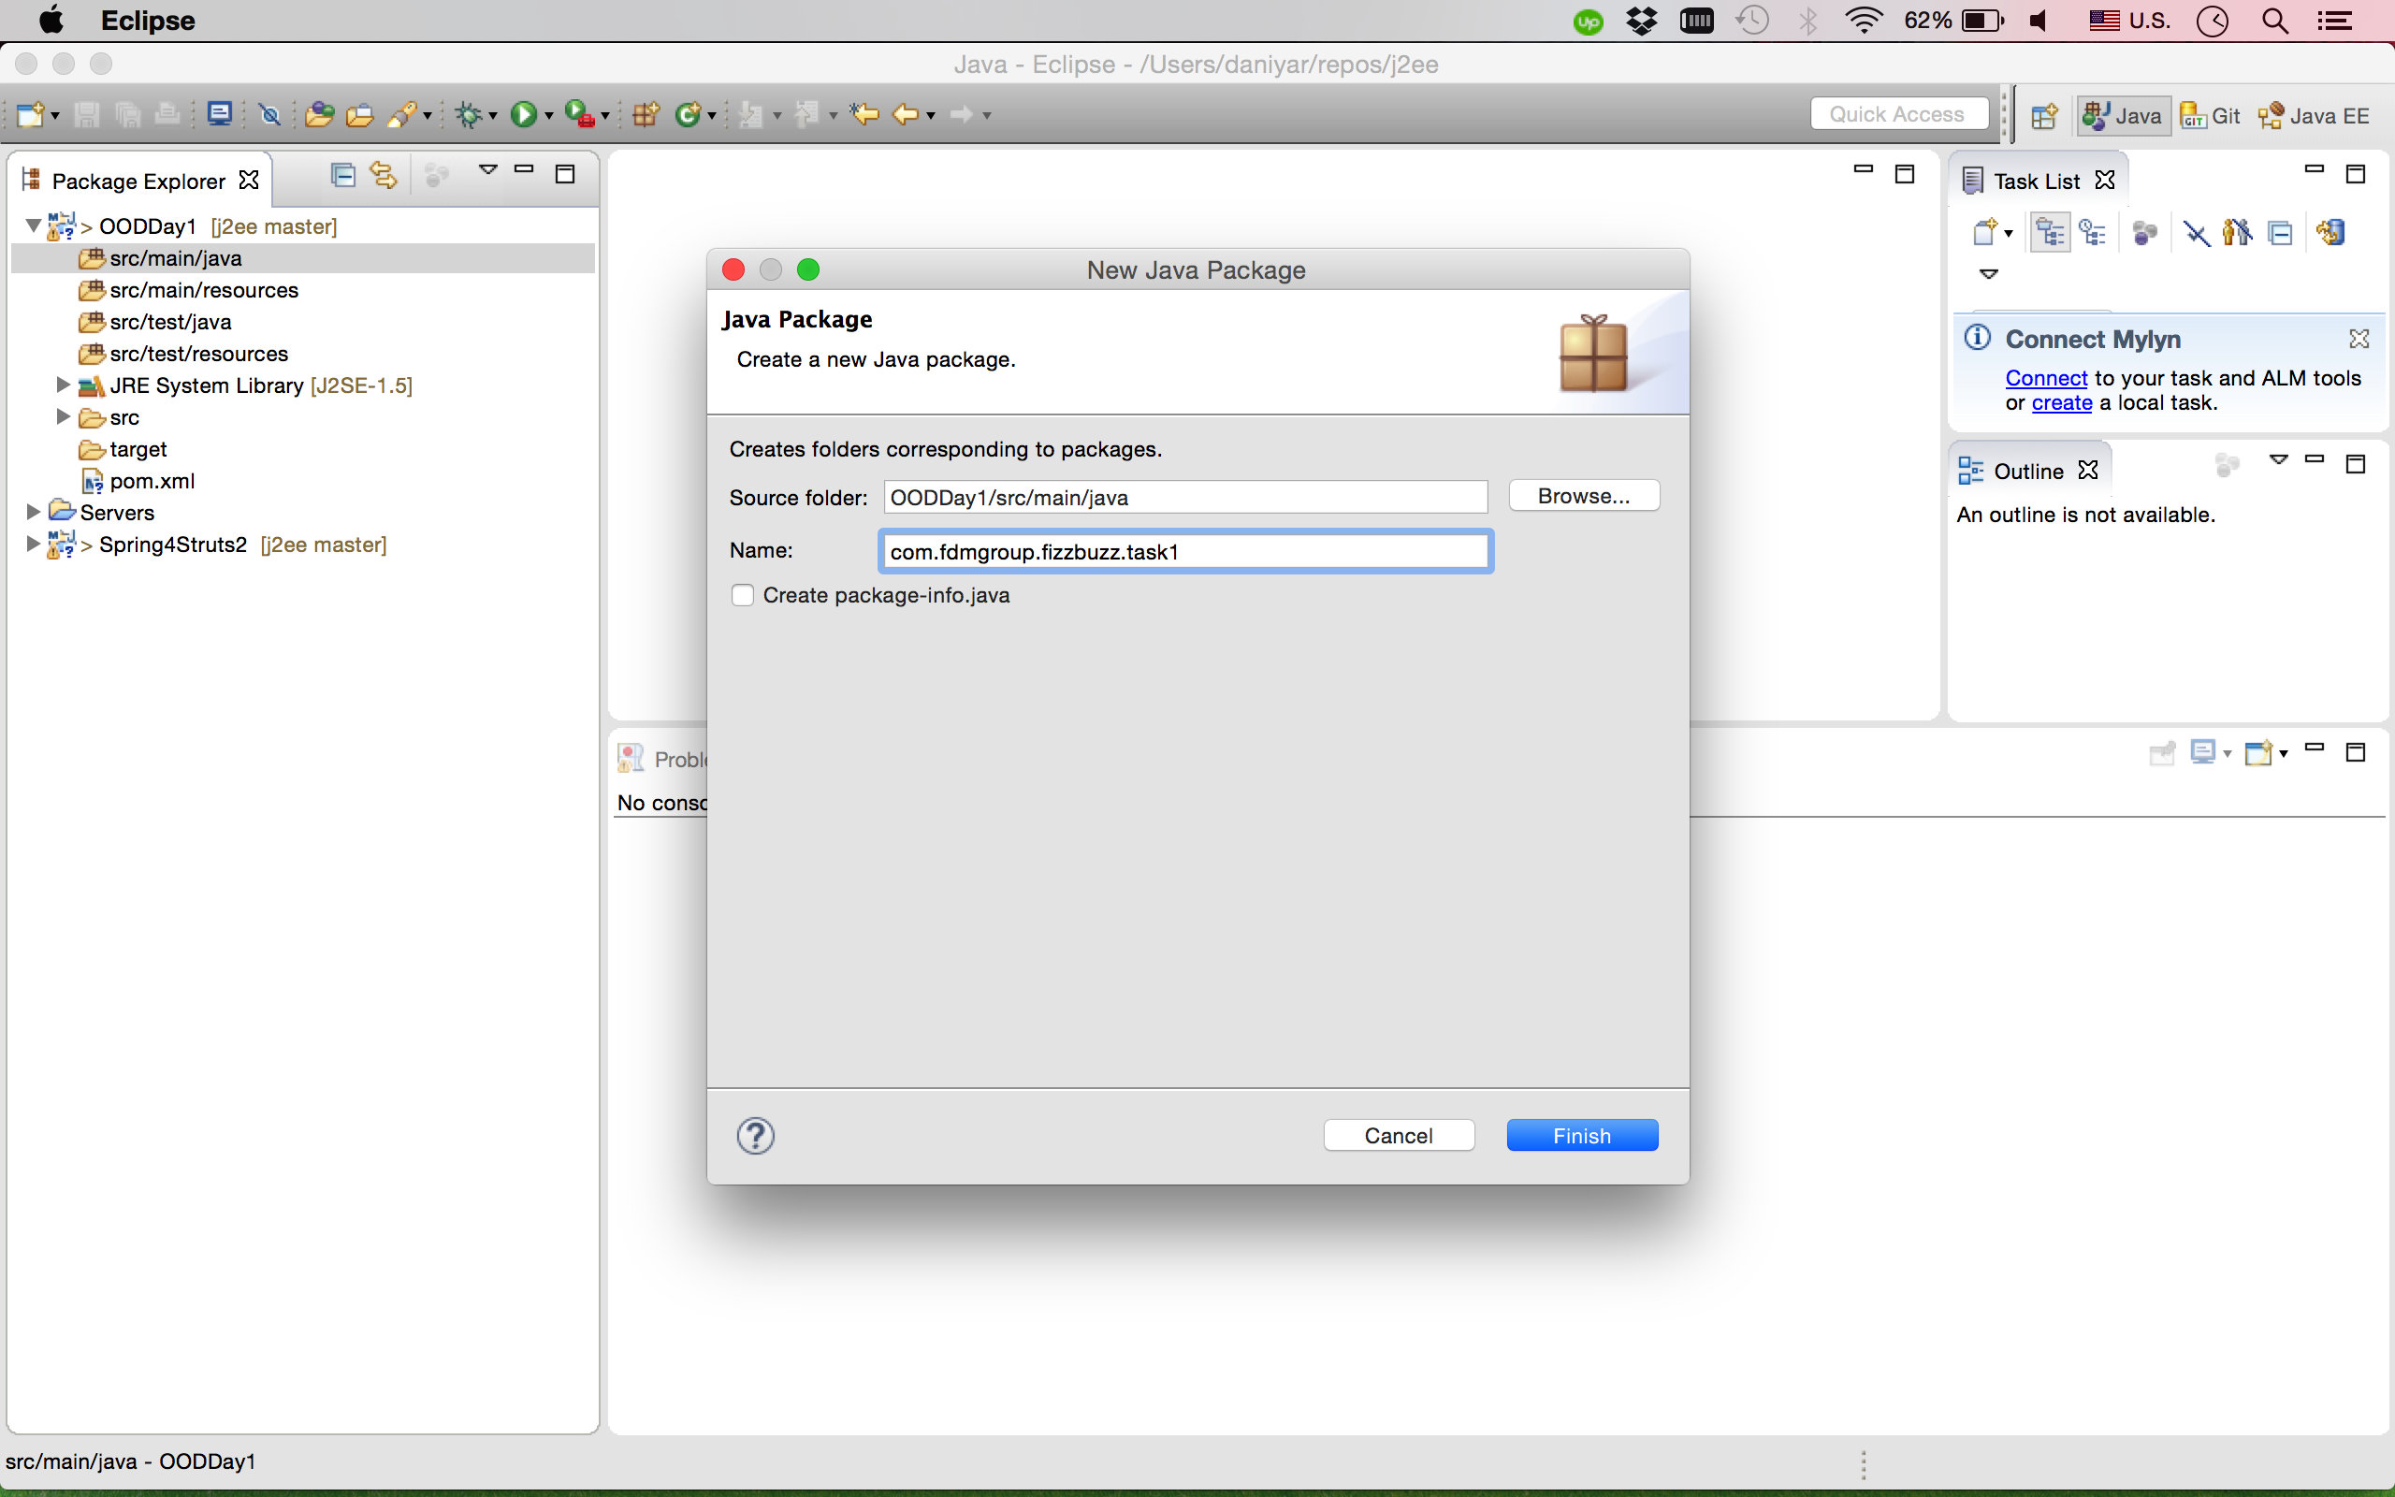

6. After that click mouse right click on created package on the menu choose New->Class

